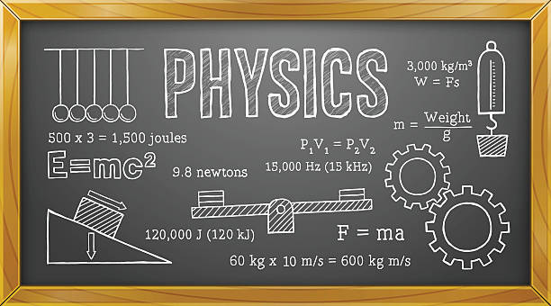
Mr. Lewis’ Physics Syllabus
Course Description
Students will develop an understanding of the movement of objects in the natural world and surrounding universe, known as the science of Physics, as well as build skills and techniques used in the outside world. This will be accomplished by conducting experiments, class discussions, reading and writing, small projects and presentations. Students will explore the scientific phenomenon allowing themselves to become scientists. This course is aligned to combine the Physical Science and Earth Science standards from the New Generation Science Standards.
Course Units/Topics
- Introduction to Scientific Inquiry
- Intro to Kinematics
- Acceleration and Forces
- Momentum
- Intro to Potential Energy
- Circular Motion and Orbits
- Waves
- Electricity and Magnetism
- Capstone Project

Grades
Students will earn a final grade each semester based on mastery of the course objectives. The formative (homework, in class work, small assignments, etc.) semester course work will comprise 20% of the final semester grade; the summative (tests, quizzes, labs, etc.) semester coursework will comprise 60% of the final semester grade; the cumulative semester exam will comprise 20% of the final semester grade. The final semester grade will be used in determining a student’s grade point average (GPA).
Course Work
WMAA is committed to providing opportunities for students to show mastery of academic standards. Communication will occur frequently between teachers, students, and their parent/guardian concerning missing work. It is the student’s responsibility to meet with the teacher to determine a plan of action to deal with missing work.
If coursework is not turned in on time, a zero will be recorded in the grade book until the work is submitted. This zero will be accompanied in the grade book with a “missing” marker so that the reason for the zero is evident. If the allowable time period to make up the work has passed, the zero will become a permanent grade.
An item of late coursework may still be turned in for a grade, but the grade will automatically have 30% taken off. Any late work turned in incomplete won’t be graded. Students will have until the unit test, which occurs at the end of each unit, to make up work they missed during that unit of study. After the unit test, all zeros recorded in the grade book during that unit will become permanent.
Any student struggling with the course work is encouraged to talk to Mr. Lewis and find a time to meet before or during school. Please e-mail and talk in person.
Testing
A student’s mastery of academic standards is determined through performance on unit tests and cumulative semester exams. The science department will provide students with limited additional opportunities to demonstrate mastery of academic standards.
Students may have the opportunity to retake a test upon request. They must notify the teacher when they would like to take advantage of this opportunity and sign up for a time agreed upon by the teacher. The score of the second test will replace the score of the first test. The teacher may choose to allow test corrections rather than a retake on certain tests, in which case students may earn half points back.
Policies and Expectations
Absence: It is very important to be in class, as each day’s content builds on the previous day’s work. When absent, it is the student’s responsibility to get all missed work and set up a time to meet with the teacher, if necessary, in order to clear up any confusion. For each day of class missed, students are allowed one day to make up the missed work. All work turned in late must be accompanied by a note explaining why it is late (so that I know that it is late due to absence). Any time a student misses class, it is encouraged that they check the course website to see what was done in class that day so that they are aware of what will need to be done to catch up.
Tardiness: All students are expected to be in their assigned seat with phone/Chromebook away and backpack under the desk before the final bell sounds. Any student that comes to class after the bell will be marked tardy for that class period. Habitual tardiness will be dealt with between the teacher, the student, and his or her family. If the problem persists, further conversations will occur between Mr. Fisher, the student, and his or her family to determine a plan of action to correct the behavior.
Academic Dishonesty: Academic dishonesty including, but not limited to, cheating and plagiarism will result in the student receiving no credit for the assessment.
Character
Additionally, students will be evaluated on their character choices for each course. The character evaluation will reflect student mastery of WMAA’s critical character expectations: be respectful, be responsible and do your personal best.
3 – Exceeding Expectations
2 – Meeting Expectations
1 – Currently Not Meeting Expectations

