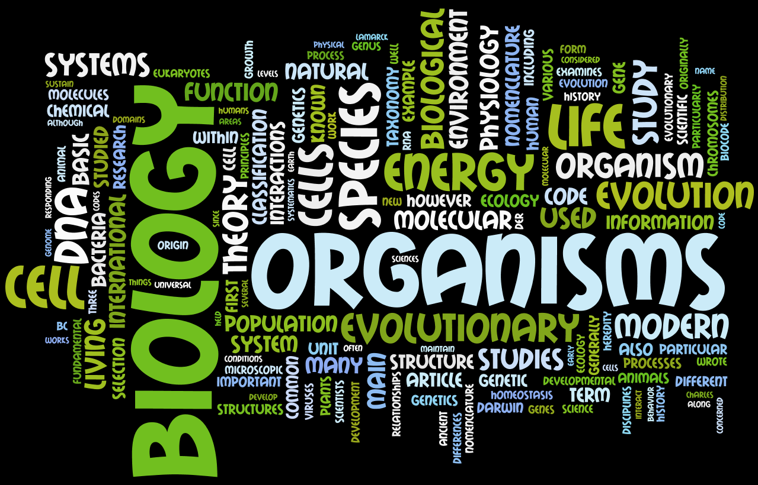
Mr. Lewis’ Biology Syllabus
Course Description
The goal for Biology is to build students’ knowledge of science and of life through the study of living systems. Students will work to develop skills and strategies for understanding science in general as well as learn to use these skills and strategies in the context of biology. This course will explore topics including, but not limited to, cells structure and function, basic anatomy, genetics, evolution, and ecology. The students in this class will be delivered course material based on the Next Generation Science Standards.
Although the biology content of this course is very important, a main focus for this course will be to better understand scientific inquiry and processes of science as they are practiced by scientists. This will be done through the use of many experiments, much writing and reading, and as much modeling of a scientist’s life as possible. We will make use of technology as well as hands-on techniques to accomplish these goals.

Course Objectives
By the end of the course, WMAA students will:
- Understand the nature of science and demonstrate an ability to practice scientific reasoning by applying it to the design, implementation, and evaluation of scientific investigations
- Explain the structure and function of organic molecules, including carbohydrates, lipids, proteins, and nucleic acids which contain many bonds that store energy
- Demonstrate the relationship of cell structures, functions, and specialization to life processes
- Describe the process of photosynthesis and cellular respiration (aerobic and anaerobic) and the role of ATP as it relates to these processes
- Explain the complex processes and interactions of cells, tissues, and organ systems that allow organisms to maintain a stable internal environment necessary for life
- Compare/contrast how genetic material is passed from cell to cell by the processes of mitosis and meiosis and explain how these processes relate to asexual and/or sexual reproduction
- Analyze the processes of replication and protein synthesis (transcription and translation) as it relates to DNA/RNA and explain how mutations and genetic engineering of DNA result in phenotypic changes in the organism or its offspring
- Predict patterns of inheritance using laws of heredity and analyze these to explain variation
- Explain evolution as the result of genetic changes within a population that occur in changing environments over time and that modern evolution includes the concepts of common descent, natural selection, and biodiversity
- Analyze the dependence of organisms on environmental resources and how matter and energy are transferred throughout ecosystems
- Explain the factors that influence population dynamics, evaluate situations that disrupt ecosystems, and analyze the impact of humans on the environment

Grades
- Tests & quizzes– 55%
- Labs, activities & classwork – 25%
- Final Exam – 20%
Coursework
WMAA is committed to providing opportunities for students to show mastery of academic standards. Communication will occur frequently between teachers, students, and their parent/guardian concerning missing work. It is the student’s responsibility to meet with the teacher to determine a plan of action to deal with missing work.
If coursework is not turned in on time, a zero will be recorded in the grade book until the work is submitted. This zero will be accompanied in the grade book with a “missing” marker so that the reason for the zero is evident. If the allowable time period to make up the work has passed, the zero will become a permanent grade. An item of late coursework may still be turned in for a grade, but the grade will automatically have 30% taken off. Students will have until the unit test which occurs at the end of each unit to make up work they missed during that unit of study. After the unit test, all zeros recorded in the grade book during that unit will become permanent.

Testing
A student’s mastery of academic standards is determined through performance on unit tests and cumulative semester exams. The science department will provide students with limited additional opportunities to demonstrate mastery of academic standards.
Students may have the opportunity to re-take one test each semester by request of the teacher. There will be 3-4 tests each semester plus the final exam.

Policies and Expectations
Absence: It is very important to be in class, as each day’s content builds on the previous day’s work. When absent, it is the student’s responsibility to get all missed work and set up a time to meet with Mr. Lewis if necessary in order to clear up any confusion. For each day of class missed, students are allowed one day to make up the missed work. All work turned in late must be accompanied by a note explaining why it is late (so that I know that it is late due to absence). Any time a student misses class, it is encouraged that they check the course website to see what was done in class that day so that they are aware of what will need to be done to catch up.

Tardiness: All students are expected to be in their assigned seat with phone/Chromebook away before the final bell sounds. Any student that comes to class after the bell, but within the first 10 minutes of class will be marked tardy for that class period. Any student arrives more than 10 minutes late to a class will be considered absent for that class period. Habitual tardiness will be dealt with between the teacher, the student, and his or her family. If the problem persists, further conversations will occur between Mr. Fisher, the student, and his or her family to determine a plan of action to correct the behavior.

Academic Dishonesty: Academic dishonesty including, but not limited to, cheating and plagiarism will result in the student receiving no credit for the assessment. Restoration will be at teacher discretion.

